**ASSIGNMENT NO: 4**

**Problem Statement -**

a) Apply Data pre-processing (Label Encoding, Data Transformation) techniques if necessary.

b) Perform data preparation (Train-Test Split)

c) Apply Machine Learning Algorithm

d) Evaluate Model.

e) Apply Cross-Validation and Evaluate Model

**S/W Packages and Libraries used:**

For the following assignment, the interpreter used was Google Collab and the Primary Library used were Pandas, Numpy, Matplotlib, and sklearn which we have discussed earlier.

**Theory-**

Cross-Validation:

* + Cross-validation is a resampling technique used to evaluate machine learning models' performance on unseen data. It involves splitting the dataset into multiple subsets, or folds, where the model is trained on some folds and tested on others.
  + This process is repeated multiple times, each time using a different combination of training and testing subsets.
* Advantages:
  + Better Generalization: Cross-validation provides a more reliable estimate of a model's performance on unseen data compared to a single train-test split.
  + Efficient Use of Data: Cross-validation allows for the maximum utilization of the available data by training and testing the model on different subsets of the dataset.

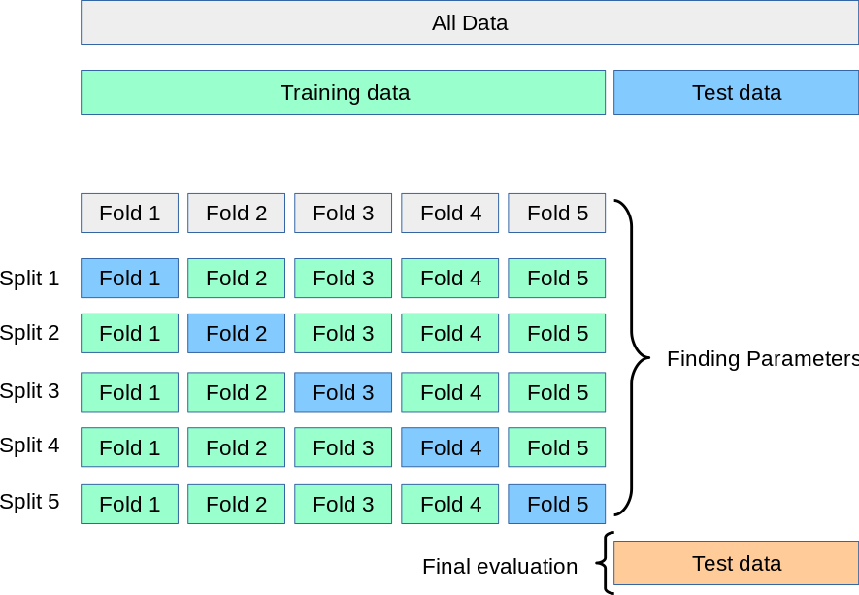

* Limitations:
  + Computationally Expensive: Cross-validation can be computationally expensive, especially for large datasets or complex models, as it requires training the model multiple times.
  + Potential Information Leakage: In certain cases, such as when feature selection or hyperparameter tuning is performed within each fold, there is a risk of information leakage from the test set to the training set.

**Methodology-**

* Data Pre-processing:
* If the dataset contains categorical variables, apply Label Encoding or One-Hot Encoding using libraries like scikit-learn's preprocessing module to convert them into numerical representations suitable for machine learning algorithms.
* Data Preparation (Train-Test Split):
* Split the pre-processed dataset into training and testing sets using train_test_split from the scikit-learn library. This ensures that the model's performance is evaluated on unseen data.
* Apply Machine Learning Algorithm:
* Choose an appropriate machine learning algorithm based on the nature of the problem (classification, regression, etc.) and the characteristics of the dataset.
* Common algorithms include Decision Trees, Random Forests, Support Vector Machines (SVM), or Gradient Boosting Machines (GBM).
* Evaluate Model:
* Evaluate the trained model's performance on the testing dataset using evaluation metrics such as accuracy, precision, recall, F1-score, or mean squared error (for regression).
* Visualize the model's performance using appropriate plots such as confusion matrix, ROC curve, or learning curve.
* Apply Cross-Validation and Evaluate Model:
* Apply cross-validation techniques such as k-fold cross-validation to assess the model's generalization performance and robustness.
* Compute cross-validated performance metrics to get a more reliable estimate of the model's performance.

**Applications:**

* Predictive Analytics: By applying machine learning algorithms to pre-processed data, businesses can make predictions and identify patterns in their datasets, leading to informed decision-making.
* Customer Segmentation: Machine learning models can help segment customers based on their behavior or characteristics, allowing businesses to tailor marketing strategies and offerings to specific customer groups.

**Limitations:**

* Data Quality: The effectiveness of machine learning models heavily relies on the quality and representativeness of the data. Poor-quality or biased data can lead to inaccurate predictions and unreliable model performance.
* Model Selection: Choosing the most suitable machine learning algorithm for a given problem requires domain knowledge and experimentation. There is no one-size-fits-all solution, and different algorithms may perform differently on different datasets.**Working:**

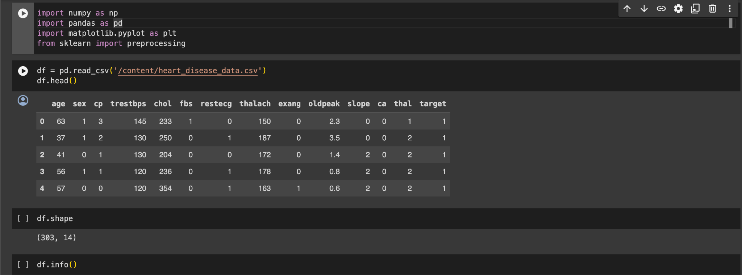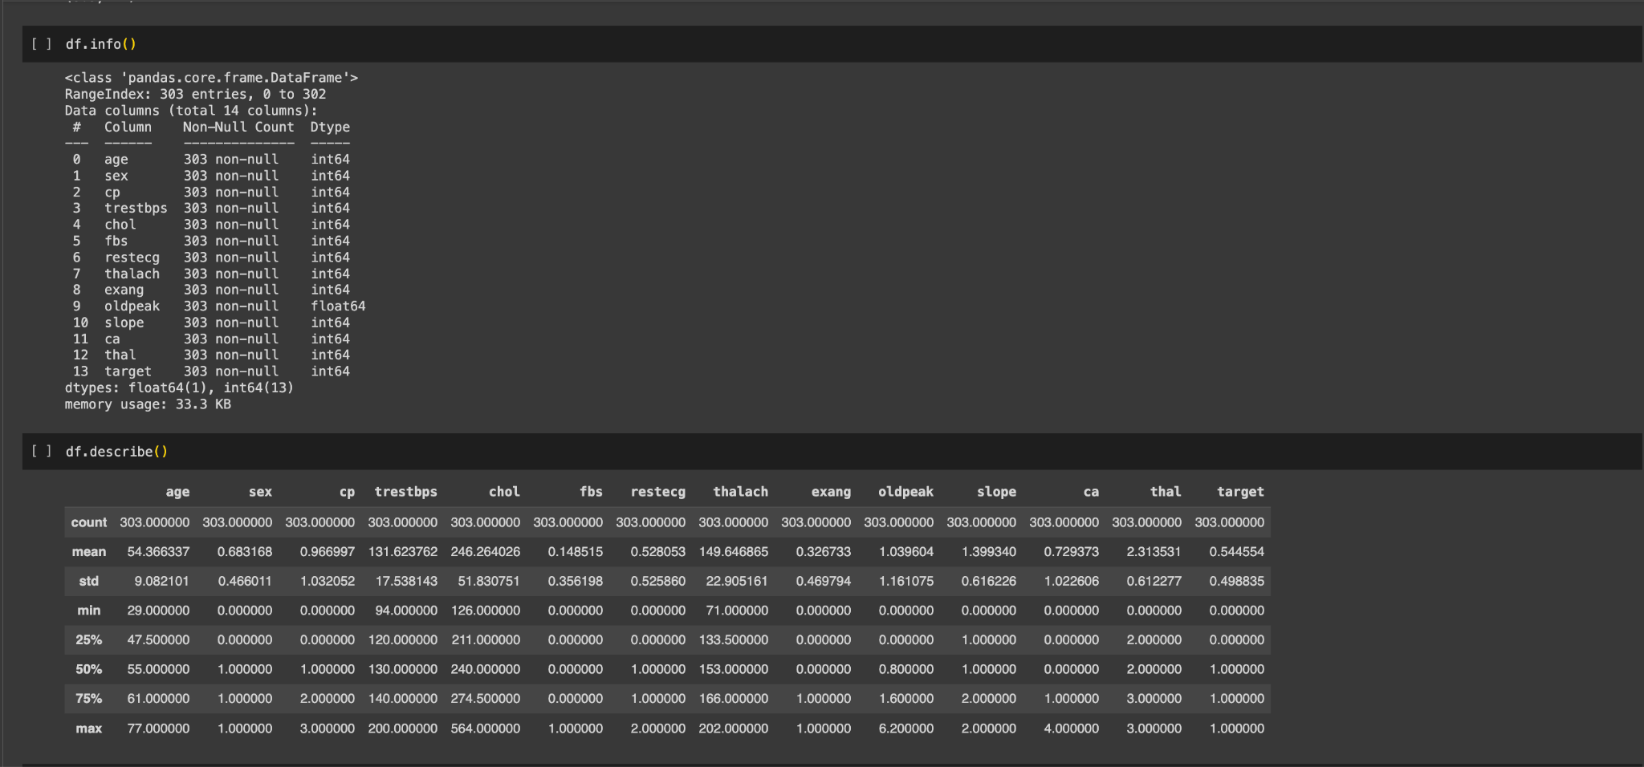

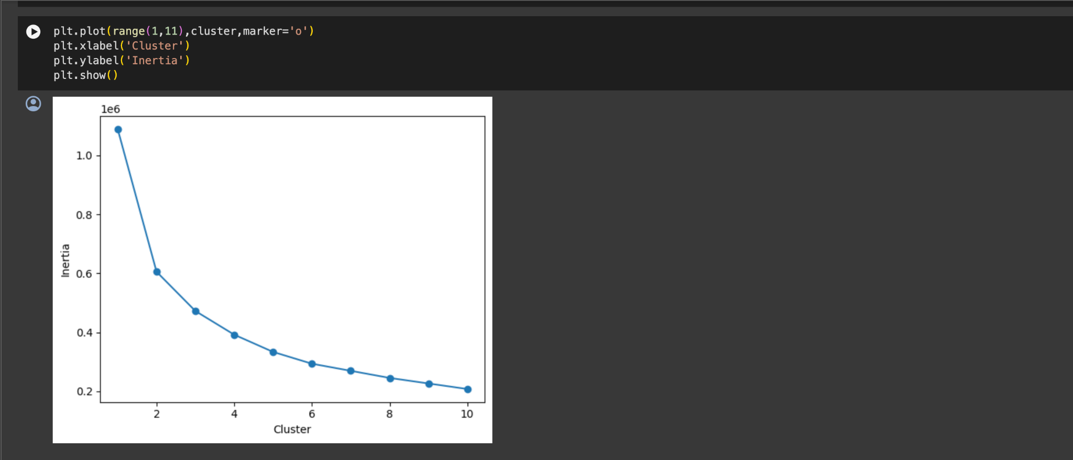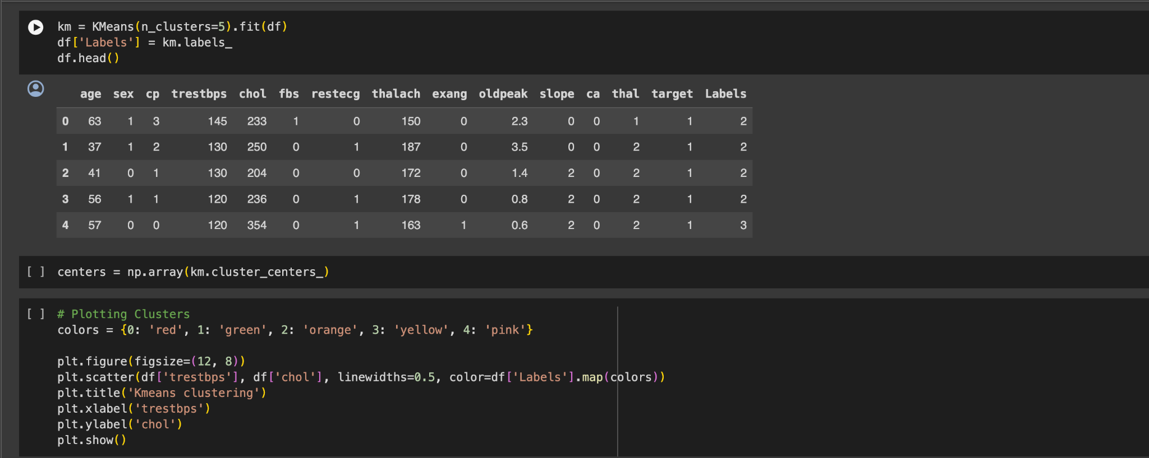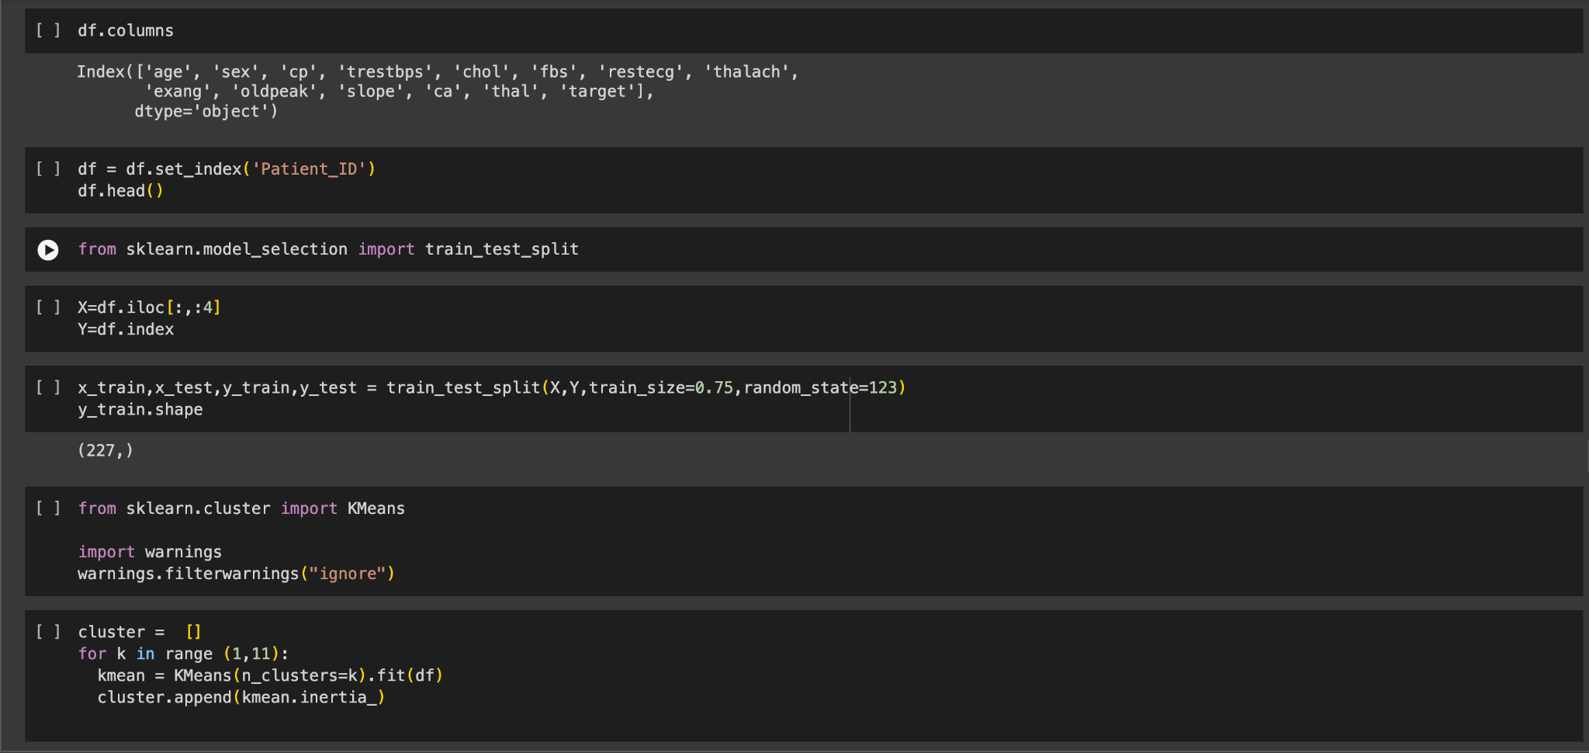

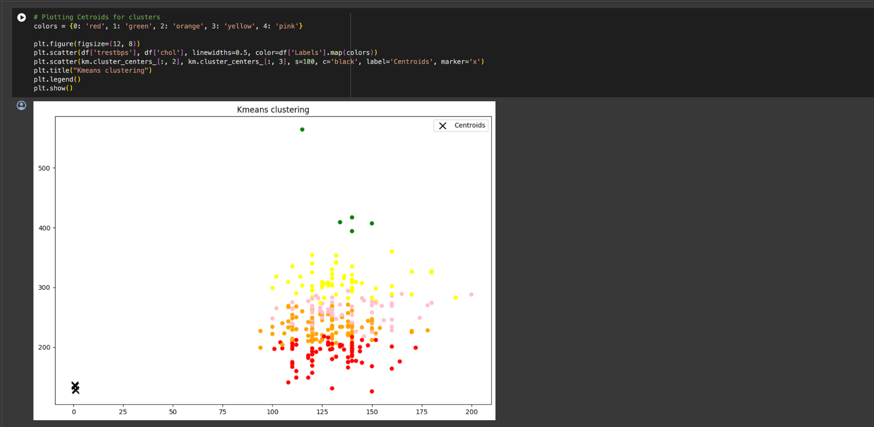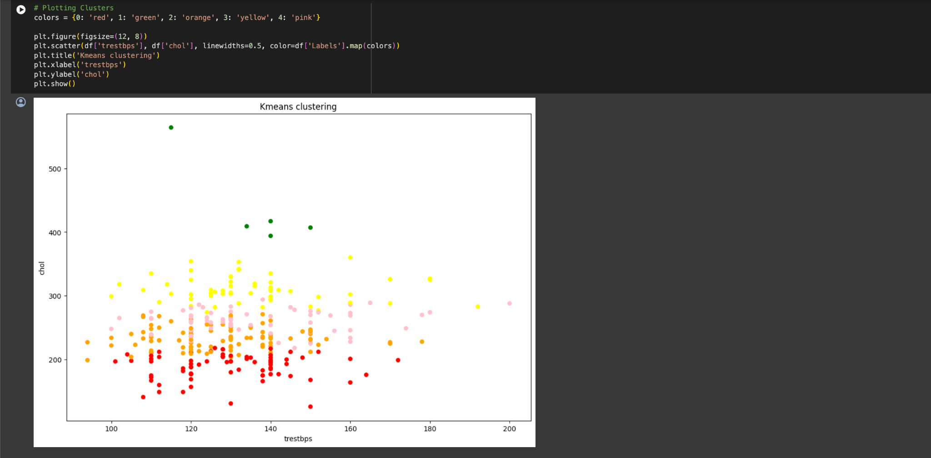

**Conclusion:**

By adhering to this methodology and understanding the assignment's applications and limitations, practitioners can effectively apply machine learning techniques to preprocess data, prepare it for modeling, train machine learning models, evaluate their performance, and assess their generalization capabilities through cross-validation.